AYNAH

Qingdao no.2 middle school of Shandong province

1.0 EXECUTIVE SUMMARY

2.0 STRUCTURAL DESIGN

**2.0 Structural Design**

As the first large space settlement community in orbit around the planet Mercury , Aynah’s structure is designed to provide considerable commercial values and ensures a safe and pleasant living and working environment for a population of 14,000 full-time residents , and up to 200 short-term visitors , enabling residents to have natural views of Mercury .

**2.1 External Configuration**

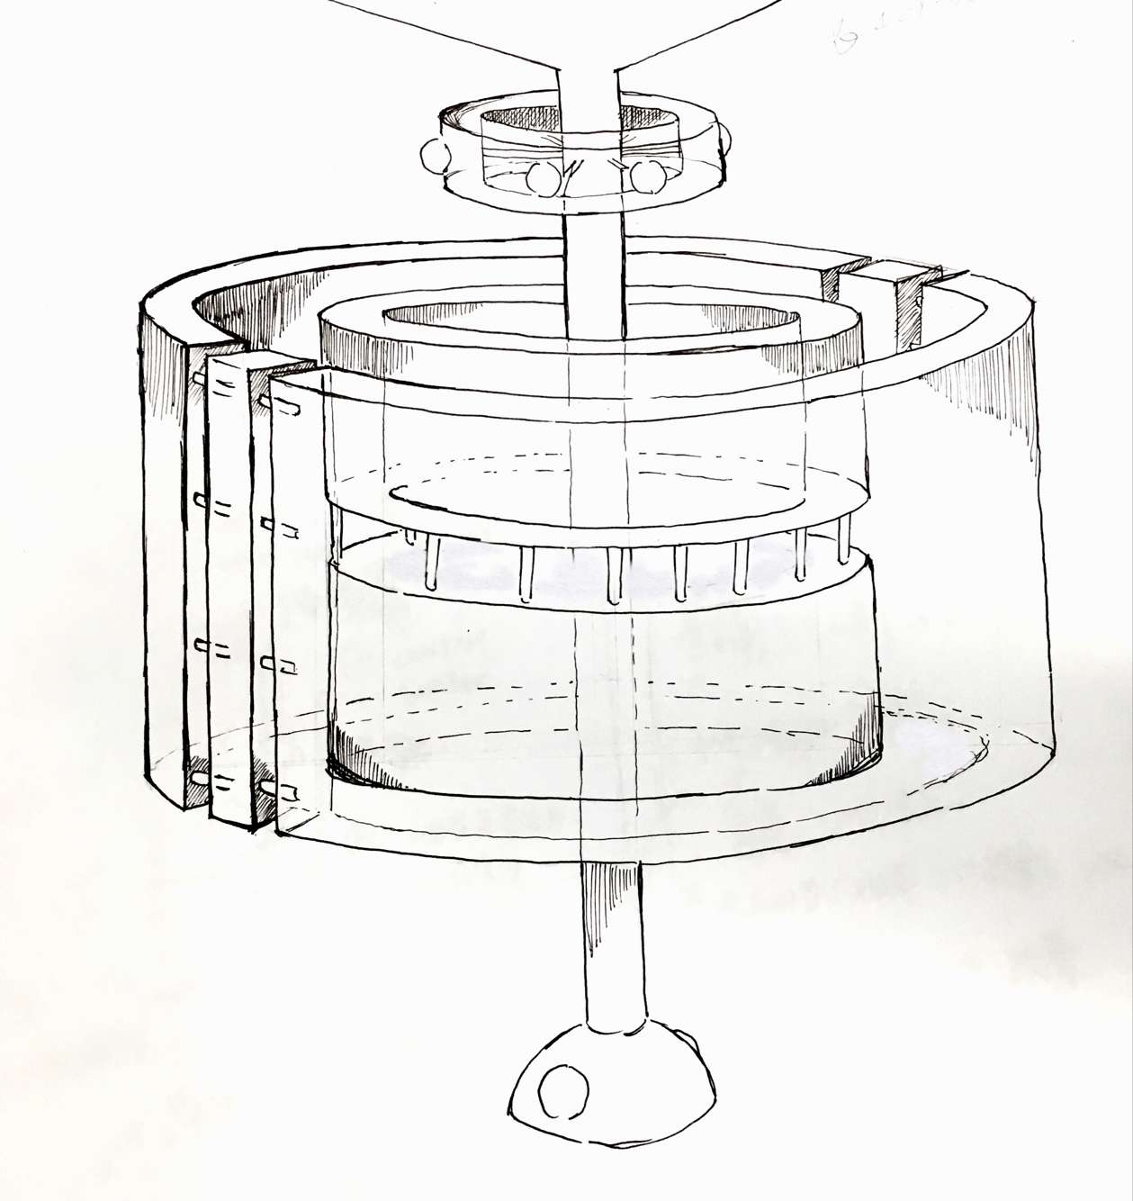

2.1.1- Design

Aynah’s design consists of the following key structural components : the central column , the manufacturing cylinder , the agricultural cylinder , the residential cylinder , the transporting and structural support spokes , the protection cover and the docking ports .

|  |  |  |  |  |
| --- | --- | --- | --- | --- |
| Key | Component | Extra rotating(except normal self rotating and revolution | Pressurized/  Non-Pressurized | Utilization |
| 1 | Central Column | N | N | A visible rotating axle. It has transporting ways inside. |
| 2 | Manufacturing Cylinder | Y | P | We mine on the mercury and refine them in our space settlement for our building and exporting to the earth. |
| 3 | Agricultural Cylinder | N | Y | Produce different kinds of food as more as we can |
| 4 | Residential Cylinder | N | Y | We offer a comfortable and convenient environment for 14,000 full-time residents , and up to 200 short-term visitors |
| 5 | Passageways | N | P | For transporting people and metals on the Mercury.One is that has pressure inside and people could walk freely. The other is that has transporting facilities in the passageways. |
| 6 | Protection Cover | Y | N | 2.1.5 |
| 7 | Docking Ports | N | N | 6 on original center 3 for people and 3 for manufacturing .it has 2 at the end of the central column for exporting refined metals to other planets. |
| 8 | Thrusters | N | N | to help the space settlement run into the correct orbit and adjust the speed and gesture of it. |
| 9 | Strengthening | N | N | Help it stronger |
| 10 | Original center | Y | P | The fist part to be sent into space with robbts,facilities ,ports and temporary living place for elites.futher more,it is the most important auto control center. |

Supplement: Y:yes N:no P:partial

2.1.2-Rotations per Minute Rate

The settlement's rotation speed is classified as 1 cycle per minute, it can simulate the rotating speed on the earth . The settlement can provide the residents with basic comfortable living conditions.

2.1.3-Initiating Rotation

(1)revolution the original center will be sent at 1305.16km from the surface of the Mercury, the right orbit, then it will begin rotating surrounding the Mercury.

(2)self-revolution

There are two parts with roll booster. The first part is on the original center., it has 3. The second is on the both sides of the idenpendential department. So, there are 7 in total .The energy mainly comes from the nuclear.

2.1.4-Artificial Gravitation Magnitudes

Artificial gravity will be produced in the following areas : the residential cylinder , the agricultural cylinder and part of the manufacturing cylinder . For the residential cylinder , a gravity of 0.7g to 0.85g is chosen as suitable environment for residents . Areas such as schools are provided with a gravity of 0.985g as acceptable development of children through their growing years requires daily exposure to 1g for at least 3 hours per earthday . A magnitude of 0.45 to 0.55 is chosen for the agricultural cylinder as it provides an optimum environment for plants’ growing . The manufacturing cylinder accommodates a gravity magnitude of 0g to 0.55g , for this is a appropriate environment for reardonium manufacturing and wider range of desirable material properties creating .

2.1.5-Protection from Radiation and Debirs

（1）The entirety of Aynah will be sheltered from the sun by the umbrella as occasion requires during violent , destructive solar activities . The umbrella is separated from the settlement and is completed at the same time. Inside the umbrella is an engine which is used to adjust the position of the settlement when the settlement is facing the sun in order to avoid the solar radiation. The umbrella is covered with shutter-like solar panels which are able to change the slopes according to the position on the track and the intensity of the sun and adjust the transparence as well to provide light for the settlement. Generated electricity will be transferred through electric cable or microwave back to Aynah .Whenever a massive meteorite full impedes the settlement from shifting to the safe zone, the umbrella can be used for cushion the strikes of meteoroids and change the direction of them.

（2）The ektexine of the space settlement is made of the metals mined and refined on the Mercury which is lightweight ,strong ,self-lubricating , against heat cold and radiation. It is the best space metals.

(3)our settlement is completely surrounded by a 0.5m layer of water ,it helps hold the temperature of the surface.

2.1.6-Construction Material

Refer to 3.1.2

2.1.7

Volume of different parts（m3）

Residential 4.31^108

Agricultural 1.3^108

Manufacture1.57^108

Central column 1.26^106

Original center1.875^105

2.1.8

2.2 Internal Arrangement

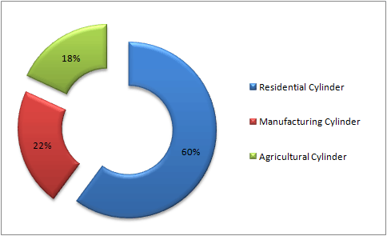

2.3.1 Construction Process

The following sequence of images shows the construction process of Aynah .

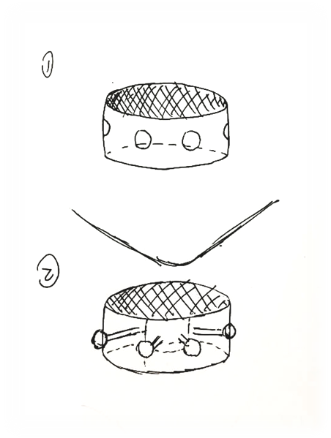

Phase 1 : The original center is sent to the orbit around Mercury .the structure of the ports stretch out, the robots finish building the ports so that the things can be brought to settlement.

Phase2: the structure of the ports stretch

out, the robots finish building the

ports so that the things can be brought

to settlement and the protection cover

opens for electricity collection and protecting

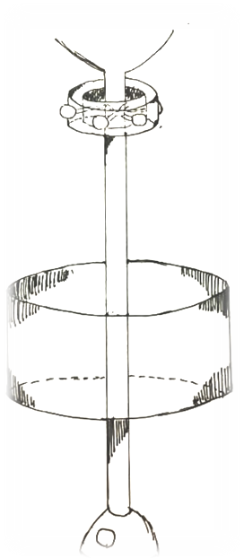

Phase 3 : The manufacturing cylinder

is completed . The docking ports on

the lower parts of the central column

are finished .

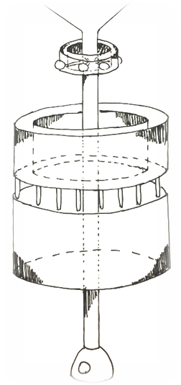

Phase 4 : The agricultural cylinder is completed .

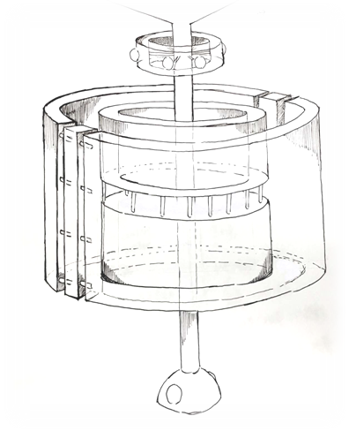

Phase 5 : The residential cylinder

is completed .

6 : All the transporting and structural

spokes are completed .

2.3.2

We use the self-revolution about 1 circle/min to make the artificial gravity

2.4 Reardonium Production in space settlement

(1)For0-0.5g our design has covered the 0-0.5g area

(2)For 0-20psi ,our assembly line is consisted of several independent rooms which can be adjusted about the pressure inside.

3.0 OPERATIONS AND INFRASTRUCTURE

3.1.1

Aynah’s orbit altitude is about 1305.1640km from the surface of the Mercury.3545.1640km from the core of the Mercury. In this altitude, aynah will have an orbital period of 24 hours, to make day alternates with night like earth. And in this altitude, the orbital speed is about 20 m/s.

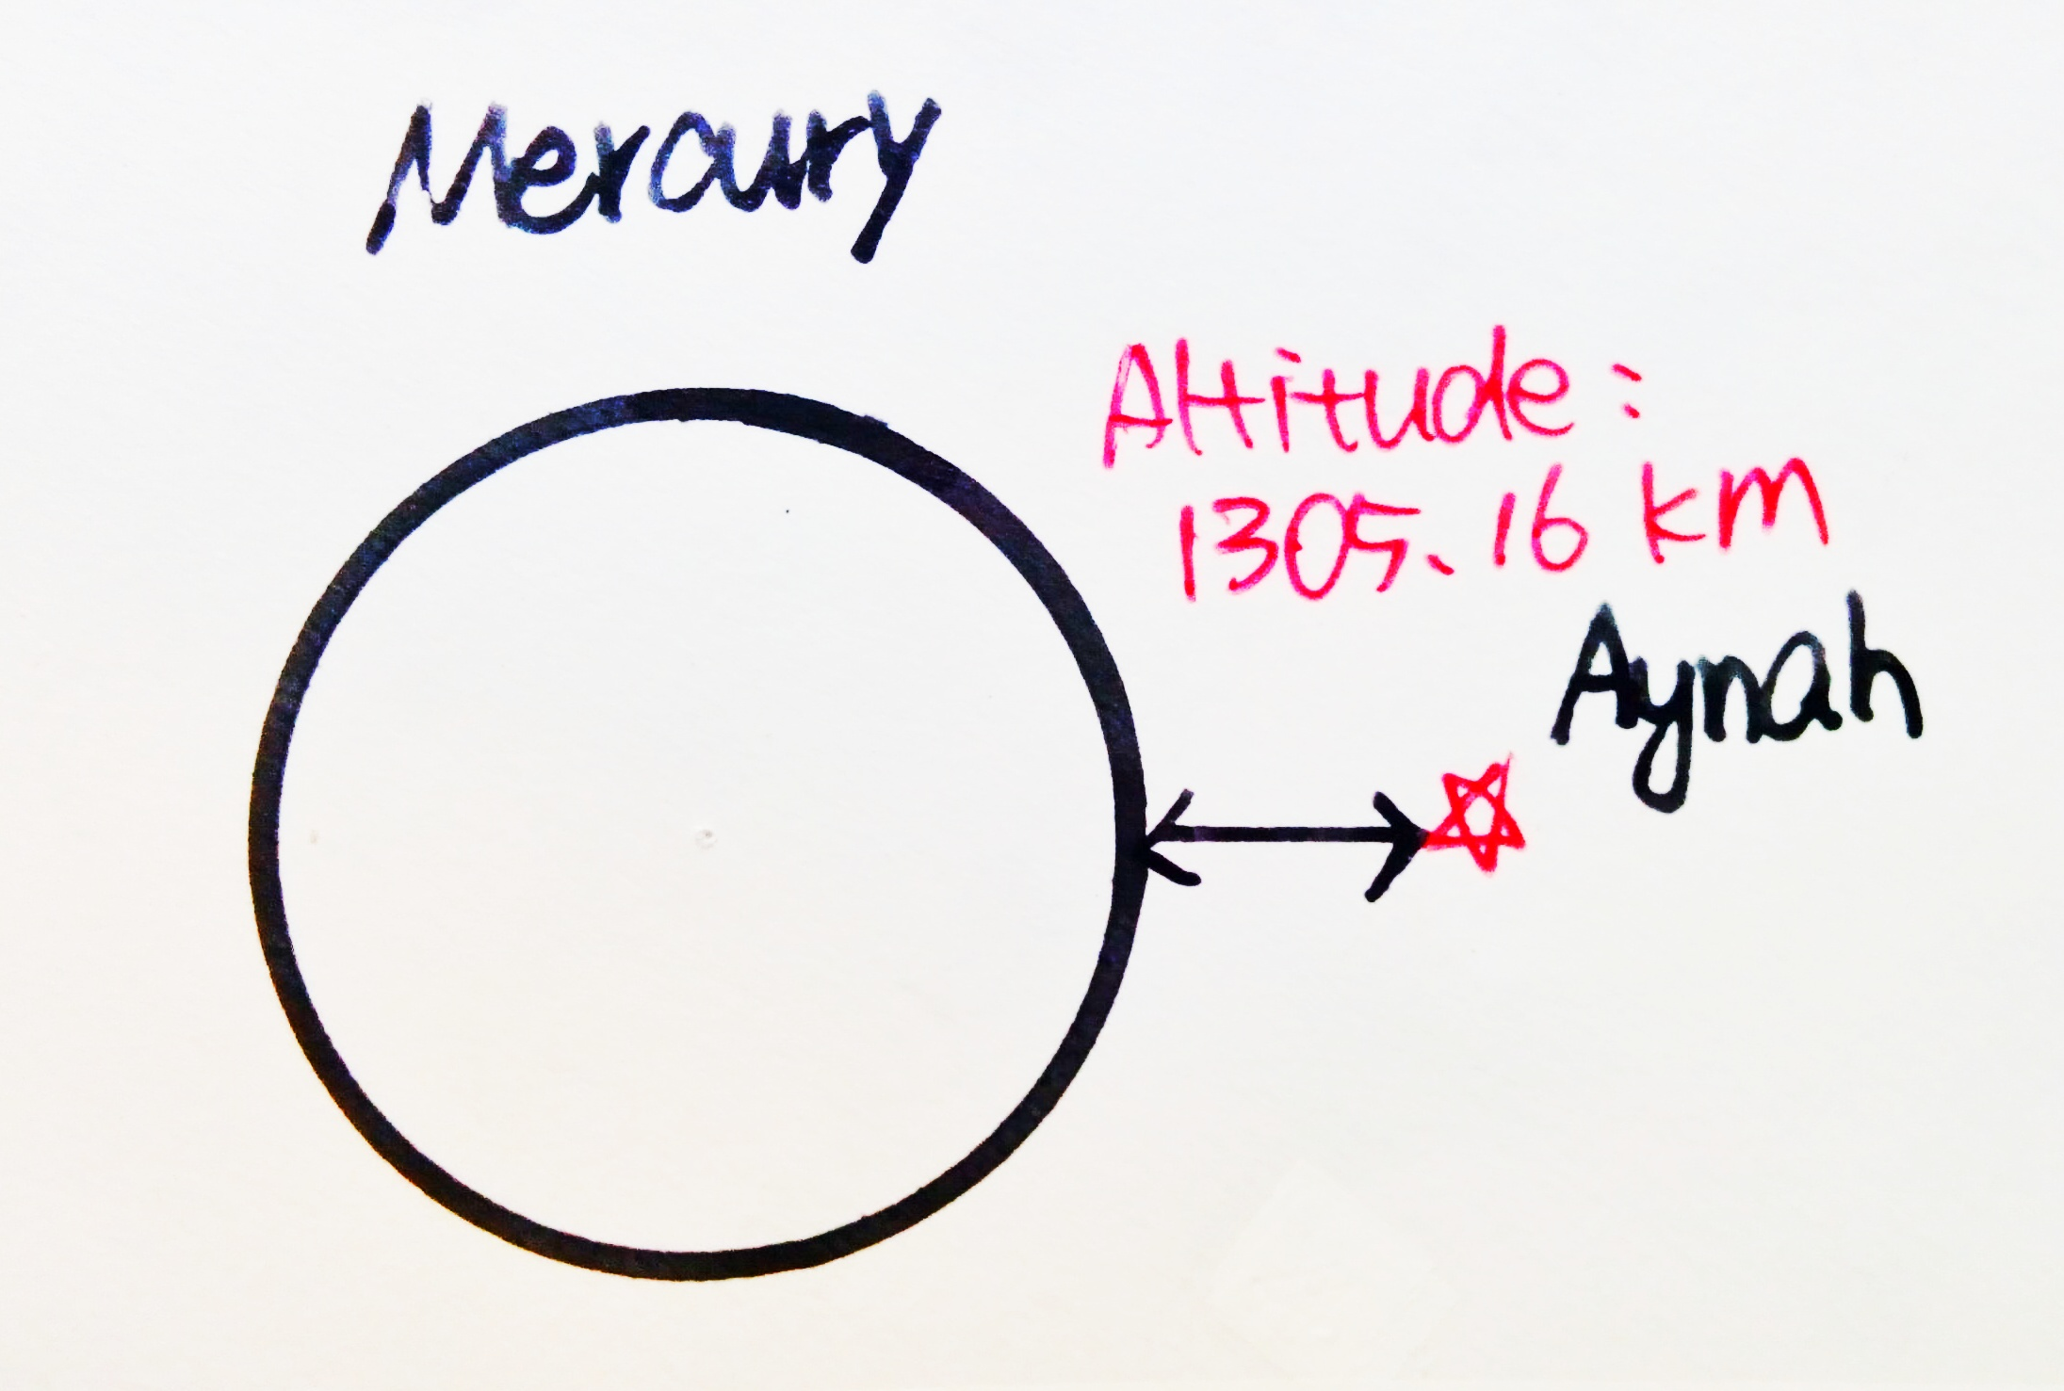

3.1.2 Sources of materials

|  |  |  |  |
| --- | --- | --- | --- |
| Material | Use | Consumption | Application |
| Titanium Alloy | Exterior |  | Applicated for exterior construction due to low density |
| Aluminium Alloy | Structural |  | Framework and structural support |
| Organosilicon | Surface |  | Heat insulation |
| Plastics | Interior |  | Applicated for interior construction due to its resistance to corrosion , high flexibility and insulating property |
| Copper | Wiring |  | Applicated for wiring due to excellent electrical conductivity |
| Nuclear Fuel | Power |  | High efficient energy supply |
| *Glass | Interior |  | * |
| *Mineral from Mercury | Complex Utilization |  | * |

*Special Materials In Residential Area And Commercial Area:

1. Architectural Surface Glass: Tough, thermally durable,display enabling.
2. Architectural Display Glass: Pristine surface, electronics enabling, touch sensitive.
3. Appliance Veneer Glass: Seamless design, electronics enabling, scratch & smudge resistant.
4. Flood Light: Artificial illumination having a broad beam.
5. Work Surface Display Glass: Durable, versatile, application enabling.
6. Wall-Format Display Glass: Large scale, seamless design, touch sensitive

*Mineral from Mercury

1.Graphite : for pyrometallurgy , heat-resisting material , abration-resisting lubricant

2.Silicate Material : for construction due to its thermostability and volume stability

3. Metal : Complex utilization

4.Reardonium : For manufactural demand

3.2 Basic infrastructure requirement

3.2.1 Atmosphere\climate\weather control

To construct a perfect environment which is similar to the earth , Aynah has a circulating system of air arrangement controlled by the Automation Control Center (ACC) . Both of the floating watchers and settled watchers can check on the air condition , the information will be sent to ACC directly . There will be an air-vent every single ten meter , the air will be filtered and purified. Pressure will be stabilized at 14.69psi to create the imitation of earth .

|  |  |  |
| --- | --- | --- |
| Gas Composition | Density | Reason |
| Nitrogen | 76.5% | _____________ |
| Oxygen | 23.5% | The perfect ratio for human living |
| Argon | 0.93% | _____________ |
| Carbon Dioxide | Minor | _____________ |
| Water Vapour | Minor (ACC will ensure that air relative humidity is regulated at 40% to 50%) | The best proportion of air relative humidity for human’s feeling comfortable , it’s hard for bacteria to live long . |

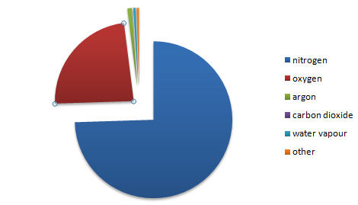

In order to create the phenomenon of day and night , sunlight will be reflected into the settlement . There will be a viewfinder every 200 meter , it provides glorious view of the space , and also , providing natural sunlight at proper time .

3.2.2food production: agriculture area

food demand: (1 person each day)

cereal crop: 300-500g

vegetables: 400-500g

fruit: 100-200g

meats:125-200g (aquatic product:50g egg products:25-50g domestic fowl:50-100g)

coffee&tea

(total capacity)

cereal crop: 5600kg

vegetables: 6300kg

fruits: 2100kg

meats:2100kg

|  |  |  |  |  |  |
| --- | --- | --- | --- | --- | --- |
| food demand | cereal crop | vegetables | fruit | meats | coffee&tea |
| 1 person each day(g) | 300-500 | 400-500 | 100-200 | 125-200 |  |
| total capacity each day(kg) | 5600 | 6300 | 2100 | 2100 |  |
| total capacity each year(t) | 2044 | 2299.5 | 766.5 | 766.5 |  |

output of common farm produce ( 1 mu each year)

| wheat | paddy | carrot | cucumber | tomato |
| --- | --- | --- | --- | --- |
| 600kg | 700kg | 4500kg | 1000kg | 2000kg |

some particular examples of planting equipments:

tomatoes(and other vegetables with short growing period

constant-temperature:25°C

reason: growing period of tomatoes is much shorter than most of crops, relative independent equipment provides more convenient method to pick mature fruit.

carrot( root of plants

The eatable part of the carrots is the root so this kind of plants needs deeper groove to grow its root.Also, when utilizing drip irrigation, the pipeline would go though the soil in order to maximize the utilize rate of the water.

paddy

special irrigation

different from the carrots, the usable part of the paddy is its seed and fruit, as a result, the larger ratio of the vacancy would lead to the higher output.

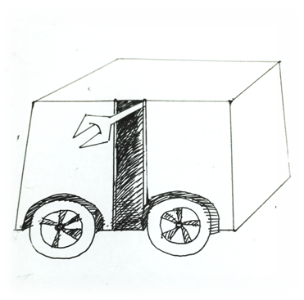

wheat

common groove

design of plucking robot

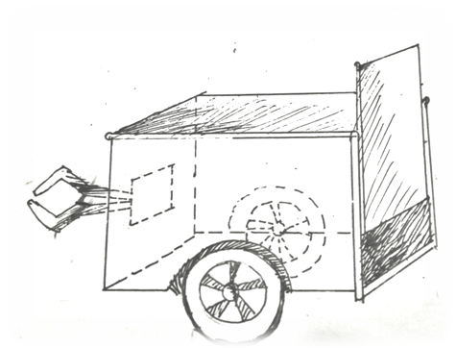

3.2.3 electrical power generation

3.2.4water resources management

Frozen water from the Mercury is the main water source. The water used in manufacturing cylinder, agricultural cylinder, residential cylinder can respectively circulate.

1 drinking water: extraction from Mercury

2 water for pressing need: artificial water

preserve: in Mercury

utilize: extract when necessary

3 domestic sewage’s reuse

connect the urban sewer to the agriculture area, put the domestic sewage into reuse.

utilize the transpiration to purify the domestic sewage and exploit the nitrogen in the urine.

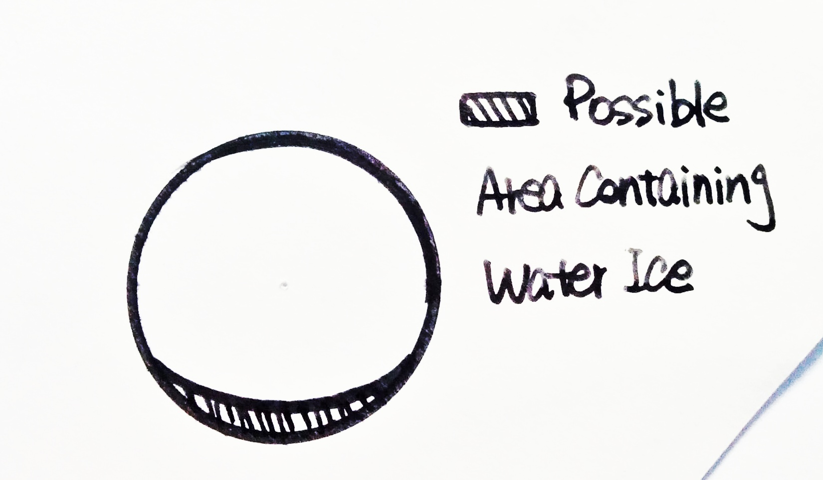

3.2.5 waste management

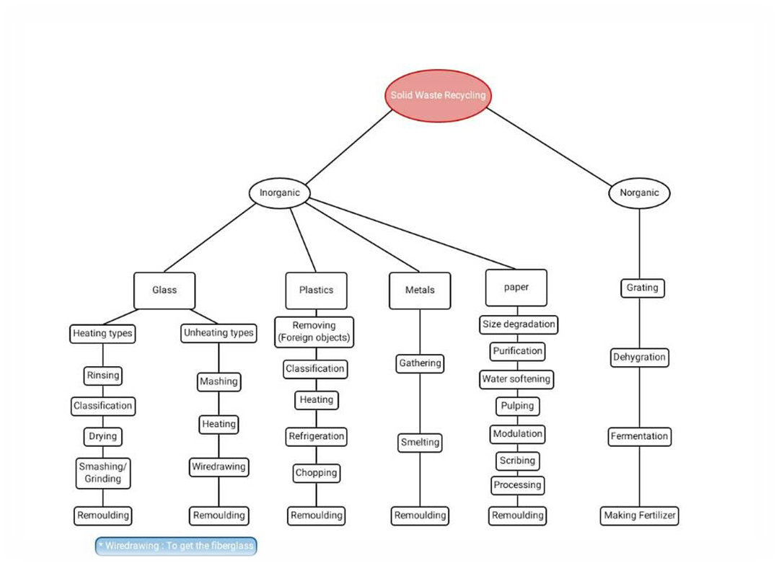

Manufacturing effluents: We separate the metal and water with metal precipitation. As industrial water doesn't need the high quality of the water, we can just use it. Some waste water is tough to be separated then we'll use elements separate technology.  
  
agricultural effluents: All the water we used here can be evaporated itself and then changes into rainwater. But because the water we need is much more than rainwater, purified water from the Mercury is always necessary.  
  
residential effluents: The waste water can be divided into available (such as urine, used rice water, tea...) and unavailable types. Most of it is available and can be sent to agricultural cylinder by pipelines. The rest of it will be sent to manufacturing cylinder as it's a bit like industrial effluents.

3.2.6 Internal transportation systems In the inhabitant area, there is a magnetic suspension system underground. The magnetically levitated trains are controlled by the control center. Some lines are regular, and some can change their route. The trains are automatic drive. Each train carries 45 people and will have a stop every 5 kilometers.

There are many over ground transportations. People are encouraged to ride bikes , and they can buy bicycles for themselves, or use the public bicycles. There is also one kind of four legs robots that can travel at a fast speed and go over the obstacle. They can also climb a building from the outside to save people.

3.2.7 Day\night cycle provisions

3.2.8Internal and External communication

Internal communication can be accomplished by smart watch and SIM which is implanted into human’s finger .The former can enable people to keep in touch with each other , and the latter can manage the identification .

External communication will be accomplished through Microwave telecommunication technique . Aynah has a Microwave telecommunication station near ACC at the original center , information collected by it will be analyzed in time to enhance the efficiency of interplanetary communication with previous space settlements .

Space craft is also designed to transport passengers or products between Aynah and other settlements .

3.3Machines and Equipments

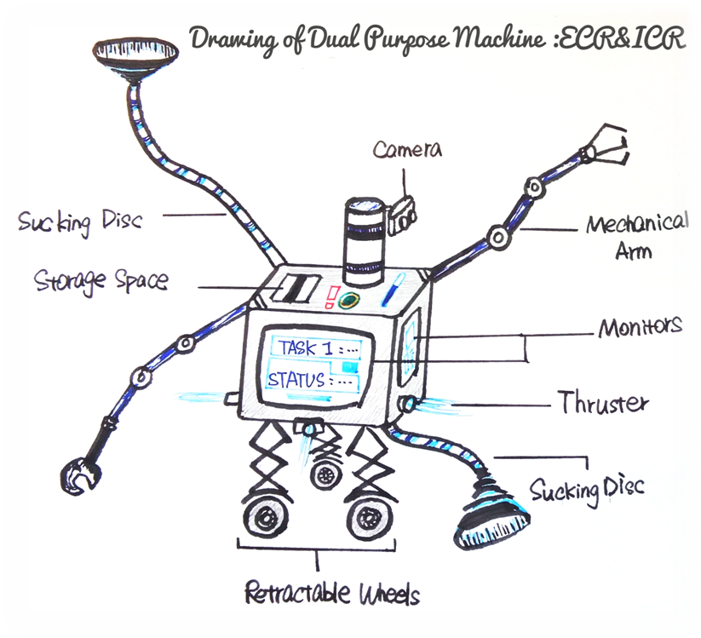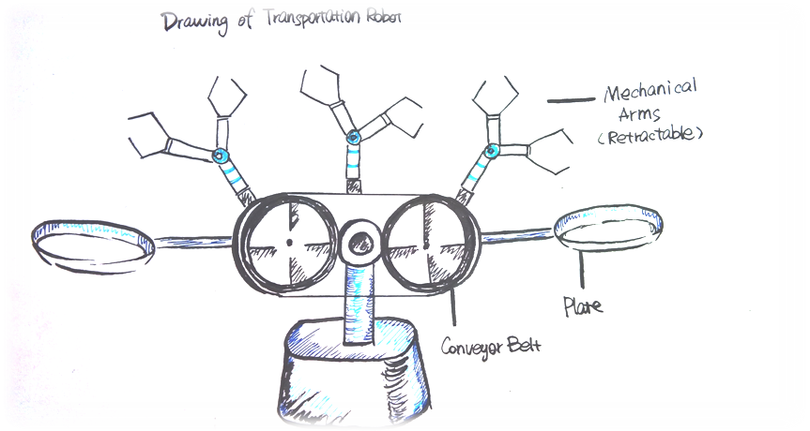

3.4solar panels

Our panels feature(1) single crystal

(2)use special dye in panel to absorb light as more as we can

(3) we will arrange panels on the surface of protection umbrella in the shape of small pieces, so that we could still adjust the gesture of the cover. Besides this, we will arrange some on the surface of the space settlement. Because the light will partially reflect away, we will change the angle to lead the light to the surface of settlement.

(4) **thermoelectric power generation due to the high temperature on the surface of the panels**

3.5 **transport vehicles**

1.its energy can be increased by charging or replacing batteries and its motor is packaged by thick insulating layer

2.it has a facility that can be combined with digging arm, then it has two functions

3.the tires are made of blades

4.0 HUMAN FACTORS AND SAFETY

4.1 Community Attributes

Aynah will provide its different residents with different living environment, a variety of consumables and enjoyable recreation facilities to ensure that its internal staff and ordinary residents have a both comfortable and wonderful daily life.

* + 1. Basic Consumable List (Free Distribution)

|  |  |  |  |
| --- | --- | --- | --- |
| Consumables | | Per Person (Per Day) | Total (Per Day) |
| Necessities | Water | For cleaning: 300L | 4,260,000L |
| For intaking: 2L | 28,000L |
| Oxygen | Adult: 360L | 4,856,400L |
| Children: 900L | 639,000L |
| Food | Calories | Man: 2,400 | 17,040,000 |
| Woman: 2,000 | 14,200,000 |
| Cereal Crop | 300~500g | 7.1t |
| Vegetable | 400~500g | 7.1t |
| Fruit | 100~200g | 2.84t |
| Meat | 125~200g | 2.84t |
| Coffee&Tea |  |  |
| Office Supplies | Ballpoint Pen | 1 | 14,000 |
| Paper | 20 sheets (A4) | 280,000 sheets |
| Staple | 8 | 112,000 |
| Printer | 1 (5 years) | 14,000 (5 years) |
| Printer Ink | 1g | 14,000g |
| Electric Drawing Tablet | 1 (3 years) | 14,000 (3 years) |
| Fax Machine | 1 (5 years) | 14,000 (5 years) |
| Toiletries | Hand Soup | 9ml | 127.8L |
| Body Soup | 3ml | 42.6L |
| Shampoo | 5ml | 71L |
| Toothpaste | 3g | 42.6L |
| Mouthwash | 40ml (only for adults) | 539.6L |
| Shaving Cream | 2ml | 28L |
| Facial Cleanser | 3ml | 42.6L |
| Medicine | Muti-vitamin  (VC,VA,VD2,VD3,VE,VB) | 1 | 14,000 |

* + 1. Community Layout

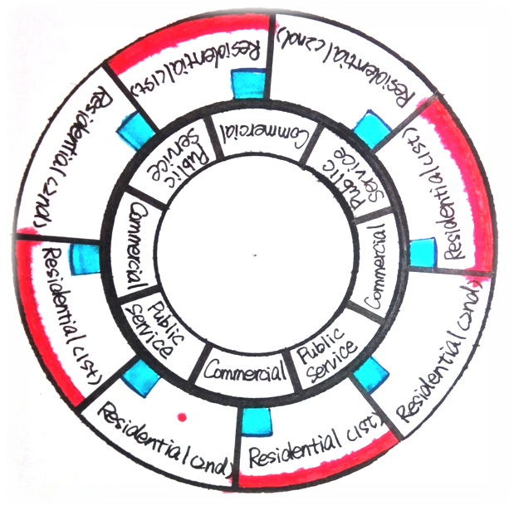

4.2 House

Aynah will provide 4 styles of houses for common residents and 2 styles of houses for visitors. All the houses will be sold on a Internet auction.

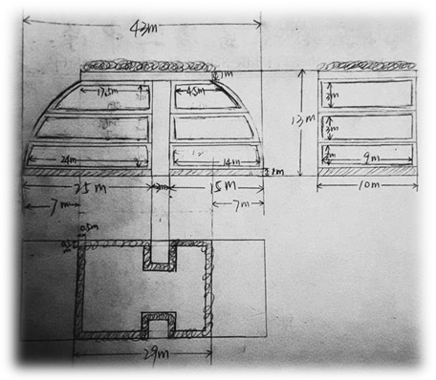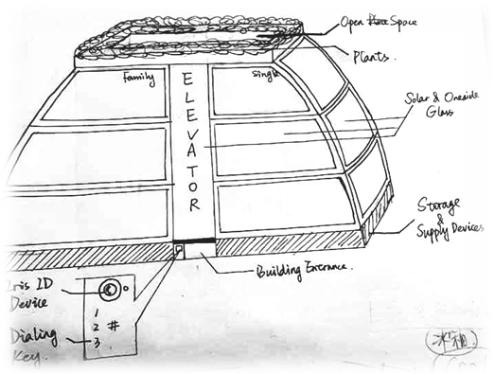

4.2.1 House Styles & Floor Layouts

|  |  |  |  |  |
| --- | --- | --- | --- | --- |
|  |  | Style | Area | Quantity |
| Residential House | House A | Single(for one) |  |  |
| Family(with kids) |  |  |
| House B | Single(for two) |  |  |
| Family(no kids) |  |  |
| Hotel  Room | Room A | Single(for two) |  | 120 |
| Room B | Family(no kids) |  | 38 |

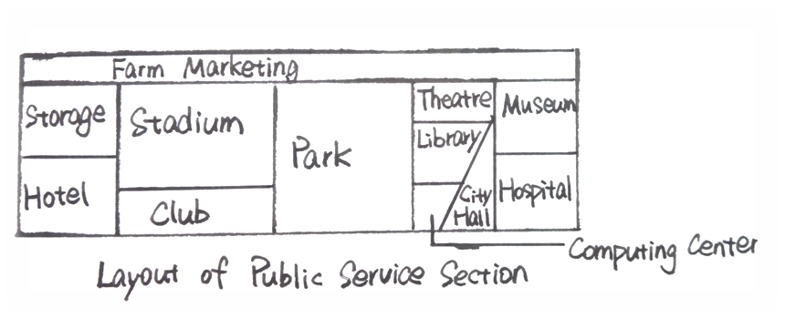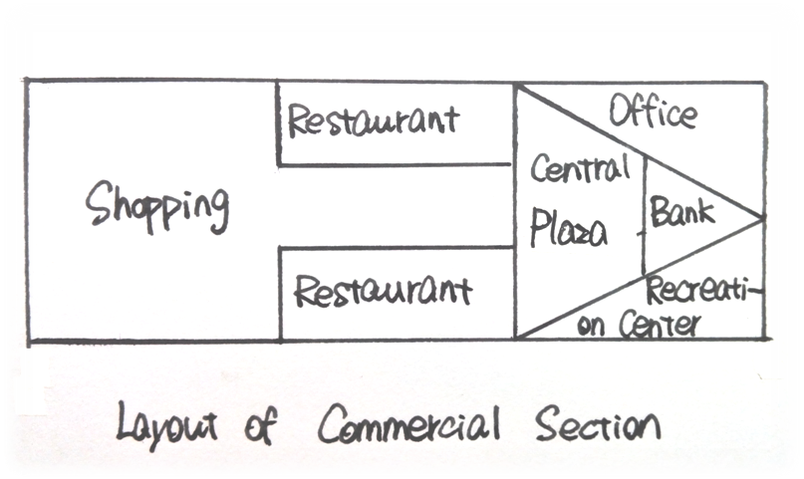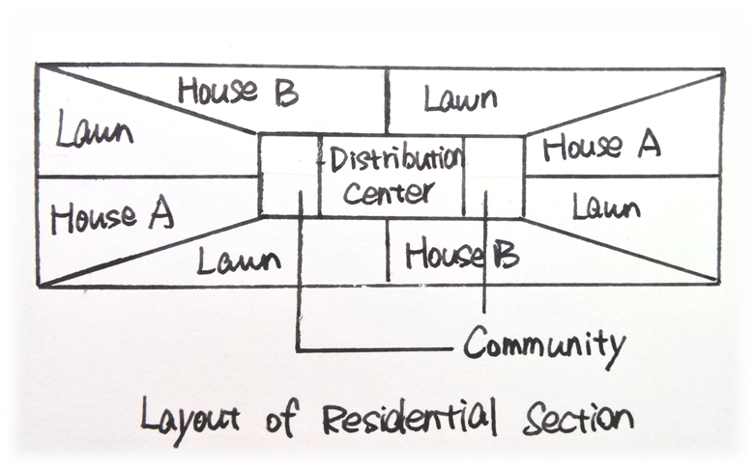

Fig. 4.2.1.1 Floor Plan of House-A (Single) Fig. 4.2.1.2 Floor Plan of House-A (Family)

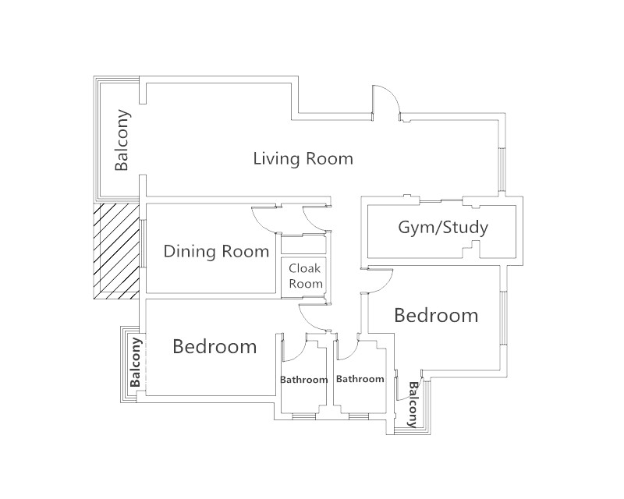

Fig. 4.2.1.3 House-B (Single) Fig. 4.2.1.4 House-B (Family)

4.2.2 Types of Furniture

|  |  |  |  |  |  |
| --- | --- | --- | --- | --- | --- |
| Site | | Type | | No. per Household | *Special Material |
| Living Room | | Sofa | | 1 |  |
| Coffee Table | | 1 | Architectural Surface Glass |
| Ped Light | | 4 |  |
| Armchair | | 1 |  |
| Dining Room | Dining Table | | 1 | Architectural Surface Glass |
| Chairs | | 6 |  |
| Gradevin | | 1 |  |
| Bar Counter | | 1 | Architectural Display Glass |
| Bar Chair | | 3 |  |
| Kitchen | Hearth | | 1 | Architectural Surface Glass |
| Built-in Oven | | 1 |  |
| Range Hood | | 1 | Architectural Surface Glass |
| Work Top | | 1 | Architectural Surface Glass |
| Curboard | | 1 | Appliance Veneer Glass |
| Bedroom | For Adult | Bed(King Size) | 1 |  |
| Night Table | 2 | Architectural Surface Glass |
| Chest of Drawers | 1 | Architectural Display Glass |
| Wardrobe(Big Size) | 1 |  |
| Peel Light | 2 | Flood Light |
| Reading Light | 2 |  |
| Full-length Mirror | 1 | Architectural Display Glass |
| Desktop Mirror | 1 |  |
| Dresser | 1 | Architectural Display Glass |
| Chair |  |  |
| For Kid  (Family Only) | Bed(Queen size) | 1 |  |
| Night Table | 1 | Architectural Surface Glass |
| Wardrobe(Small Size) | 1 |  |
| Reading Light | 1 |  |
| Full-length Mirror |  | Architectural Display Glass |
| Study | Desk | | 1 | Work Surface Display Glass |
| Peel Light | | 4 |  |
| Reading Light | | 1 |  |
| Bookcase | | 1 | Architectural Display Glass |
| Wall-Format Display Device | | 1 | Wall-Format Display Glass |
| Bathroom(2) | Wash Basin | | 2 |  |
| Closestool | | 2 |  |
| Bathtub | | 1 |  |
| Shower Cubicle | | 1 | Architectural Display Glass |

4.3.1

Spacesuit

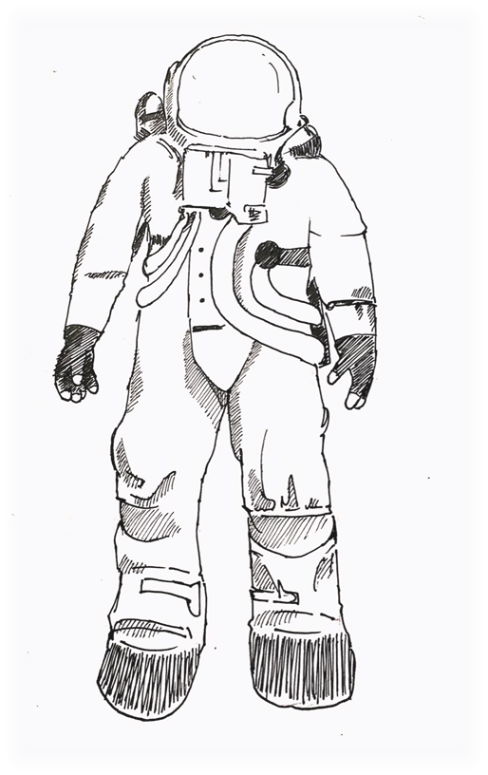

REGULAR STUFF:  
advanced suits regulate the astronaut's temperature with a Liquid Cooling and Ventilation Garment (LCVG) in contact with the astronaut's skin, from which the heat is dumped into space through an external radiator in the PLSS.  
requirements for EVA include:  
Shielding against ultraviolet radiation  
Limited shielding against particle radiation  
Means to maneuver, dock, release, and/or tether onto a spacecraft  
Protection against small micrometeoroids  
specific included : an inner liner, a LCVG, a pressure bladder, a restraint layer, another liner, and a Thermal Micrometeoroid Garment consisting of five aluminized insulation layers and an external layer of white Ortho-Fabric.   
materials:which with reduced dust retention times and the potential to control the dust exposure risks during planetary exploration.   
  
In NASA space suits, communications are provided via a cap worn over the head, which includes earphones and a microphone.（on that occassions with regular touring people,we could drop the communication devices and develop general supervise system instead.）  
pressure of pure oxygen :about 32.4 kPa (240 Torr; 4.7 psi), equal to the 20.7 kPa (160 Torr; 3.0 psi) partial   
  
 In space suits that use 20.7 kPa, the astronaut gets only 20.7 kPa − 11.7 kPa = 9.0 kPa (68 Torr; 1.3 psi) of oxygen, which is about the alveolar oxygen partial pressure attained at an altitude of 1,860 m (6,100 ft) above sea level. This is about 78% of normal partial pressure of oxygen at sea level[citation needed]  
  
type:  
  
Hybrid suits have hard-shell parts and fabric parts. NASA's Extravehicular Mobility Unit (EMU) uses a fiberglass Hard Upper Torso (HUT) and fabric limbs. ILC Dover's I-Suit replaces the HUT with a fabric soft upper torso to save weight, restricting the use of hard components to the joint bearings, helmet, waist seal, and rear entry hatch. Virtually all workable space suit designs incorporate hard components, particularly at interfaces such as the waist seal, bearings, and in the case of rear-entry suits, the back hatch, where all-soft alternatives are not viable.  
  
Skintight suits, which use a heavy elastic body stocking to compress the body. The head is in a pressurized helmet, but the rest of the body is pressurized only by the elastic effect of the suit. This eliminates the constant volume problem, reduces the possibility of a space suit depressurization and gives a very lightweight suit. When not worn, the elastic garments' may appear to be that of clothing for a small child. it use the body's natural perspiration to keep cool. Sweat evaporates readily in vacuum and may desublime or deposit on objects nearby: optics, sensors, the astronaut's visor, and other surfaces. The icy film and sweat residue may contaminate sensitive surfaces and affect optical performance.

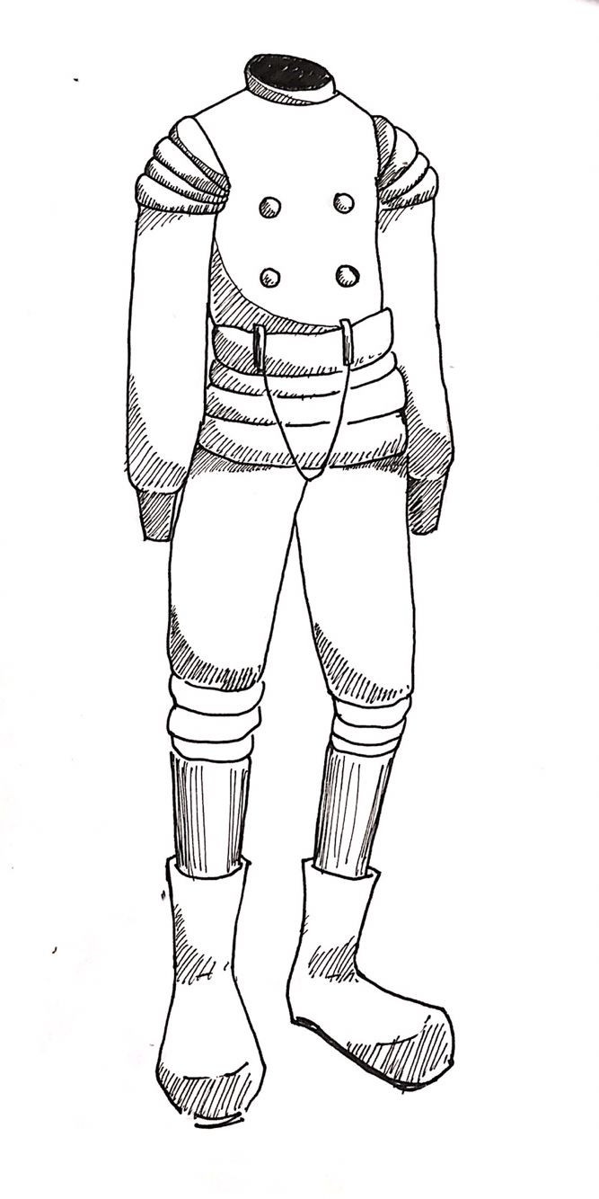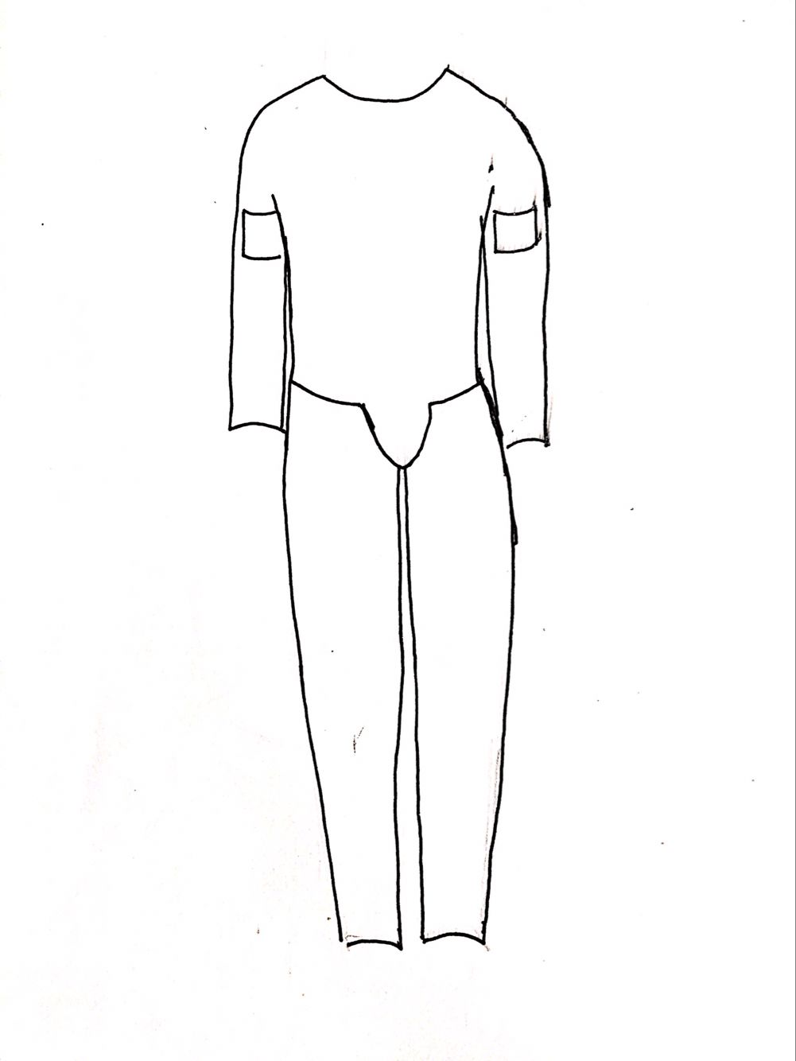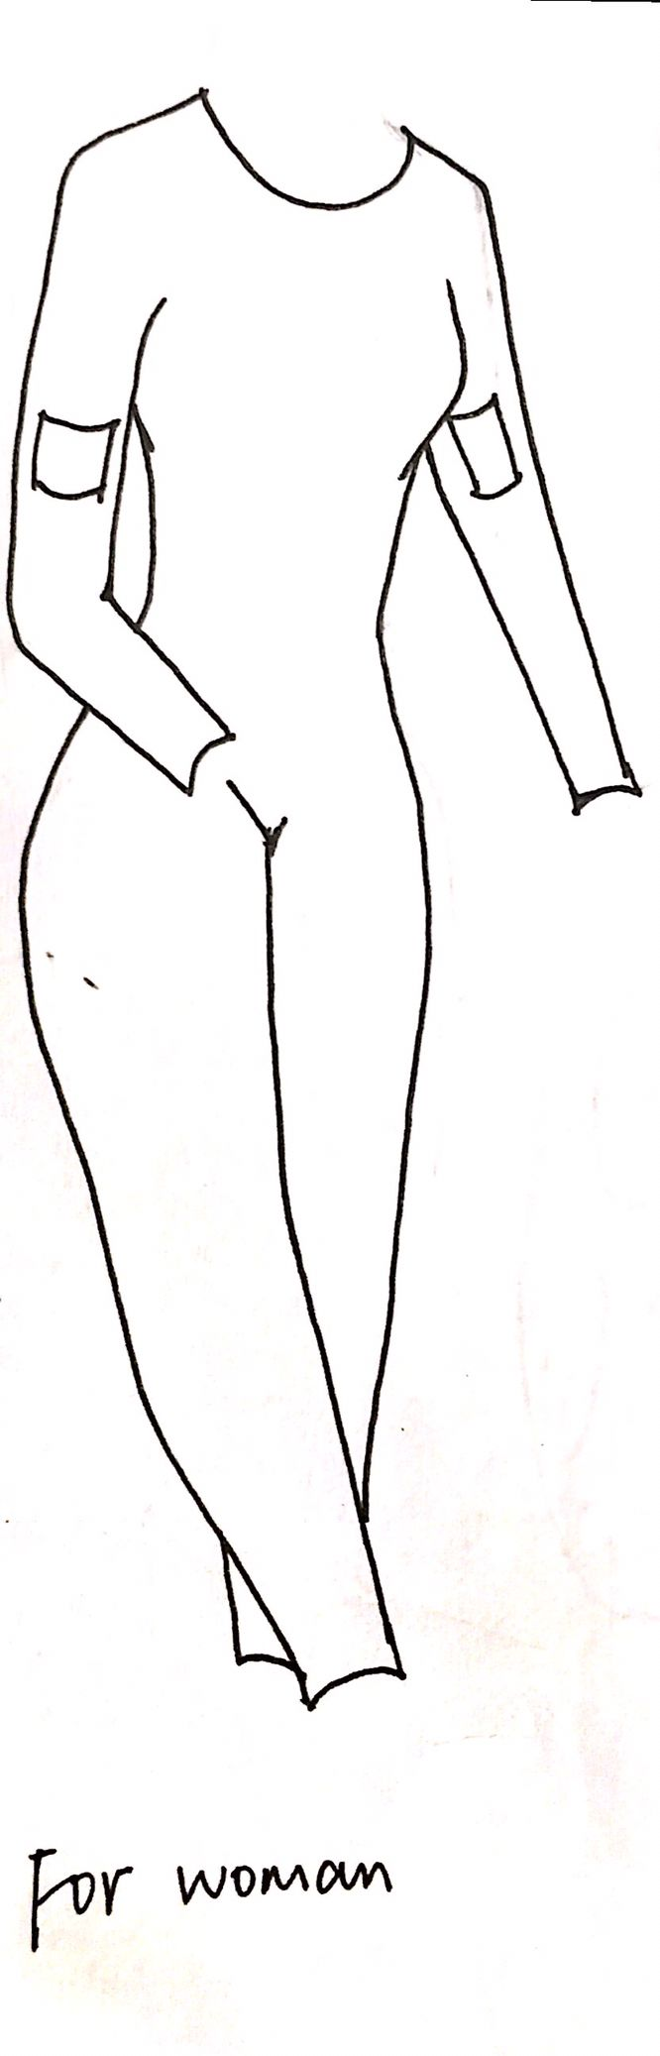

4.3.2airlock

The room is completely closed. It has two doors,one is between space and airlock,the other is between airlock and interior.it can bring air in and out .and it will check if there is any unconscious-creatures,dangerous things.then clear them out.what’s more, astronouts are able to change spacesuits and oxygen-supplying system.

5.0 AUTOMATION DESIGN AND SERVICES

5.1 Automation of Construction Processes

**Transportation :** The materials which are needed to build the devices around the control center will be carried with the spacecraft at the beginning , while the other will be transported from Mercury using the Interplanetary Material-Transportation Robot named IMTR .

**Installation :**Two mechanical arms will install equipments . Exterior construction will be finished by Exterior Construction Robot ( ECR ) , which is responsible for building exterior structure and assembling devices. Interior Construction Robot ( ICR ) will finish Interior decoration and furniture placement .

5.2 systems

5.2.1 maintenance, repair, and safety functions

There would be 12 supply stations (SS) locating in the significant parts of the Aynah's city structure, which effectively deliver the security information to the automation control center(ACC). When maintenance, repair and upload service is needed for various equipments, ACC would make injury severity scase, publish orders, conduct first-aider robots to accomplish these kinds of service.

Various equipment

Supply stations

Automation control center

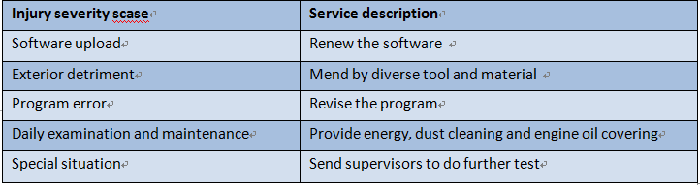

|  |  |  |
| --- | --- | --- |
| Name | Function | Measure |
| Repairment System | With the ‘ First Aider ‘, the Repairment System will undertake the resbonsibility of dealing with uncontrolable problems in Aynah .  *refer to |  |
| Security System | Security System will assure that only authorized personnel have access to the control system , data center and other confidential site . And for residents , it can  control their door locks to ensure that they can only be opened by people with hosts' approval . | All the residents in Aynah will be distributed a microchip called Smart Identity Manager . It will be implanted into everyone's forefinger , taking lots of tasks including assisting Security System to identify visitors .  *refer to 5.3.1  Lattice-based cryptography is the generic term for asymmetric cryptographic primitives based on lattices which will be used in Aynah's data storage and transmission to protect data security from quantum computer's massive decryption . |

Device

|  |  |  |  |
| --- | --- | --- | --- |
| Device | CPU | RAM | Bandwidth |
| ECR&ICR | 3.5Ghz | 64G |  |
| IMTR | 2.6Ghz | 60G |  |
| ARR | 2.8Ghz | 60G |  |
| SIM | 3.2Ghz | 62G |  |
| MRL | 3Ghz | 60G |  |

5.2.2 backup systems and contingency plans

|  |  |
| --- | --- |
| Problem | According Solution |
| External structure damage | Disperse people by exit passageway and separate the broken part by insulating wall. Send spacecrafts to mend damage structure. |
| Network failure | SS provide agent hotspot for immediate activities.  Repair networking devices. |
| Climate control failure | Seal every openings of internal buildings and utilize house control system to ensure appropriate climate inside. Require people stay indoors before the successful repair of climate control. |
| Fire | Send first-aider carrying fire extinguishing to put out fire. |
| Power outage | Emergency lithium ion batteries to support immediate activities.  Coordinate different power methods (including solar panels and nuclear reactor ) and repair power system to recover power supplement |
| Agricultural failure | Use emergency food（including hard bread, solid water, concentrated nutrients）in storeroom. |
| Control confusion | Employ backup system if necessary. Clear virus periodically to avoid this situation. |

Operation problems mentioned above could be detected not only by settle watchers but also by floating detectors. As soon as the settle watchers or floating detectors make a warning about abnormal information through the Internet, ACC would react immediately take action. Its function includes: ensure the accurate information about the problem, send it to everyone's smart watch, order tasks to according robots or equipments.

Settle watchers and floating detectors

Automation control center

Robots and equipments

Everyone's smart watch

5.3 Intelligent Equipment

5.3.1 Smart Identity Manager ( SIM )

Every resident and visitor of Aynah will be provided with a SIM, which will be inplanted into the person's right forefinger . It's 0.1cm2 in area and serves as a combination of interactive-identification chip , location-tracker and health manager. It has two standards . For

permanent residents we will provide permanent SIM , which can be combined with muscle and exist forever. The other kind of SIM has a shell manufactured with absorbable material .

|  |  |  |  |
| --- | --- | --- | --- |
| Standard | Shell | Power | Biodegradability |
| Permanent | unabsorbable | bioelertricity | × |
| Temporary | absorbable | electric battery | √ |

Function：

Interactive-identification chip :

The chip uses a strong encryption near field communication protocol . Only in the distance of 1.5cm can it be detected , so it can works with fingerprint identification together . The Security System will confirm it when the user putting his index finger tip on the identity recognition device ,with a changing key carried on bioelectric information from SIM via user's muscle and skin , user's fingerprint and the electrical signal of user’s unique heart rate that SIM identified . ECG information is unique, depending on the exact location and size of each person's heart. And as soon as SIM is implanted into human body , it will be combined with cells around it to prevent being taken out . Quintuple Security will maxmize Aynah's safety .

Location-tracker :

SIM is Integrated with a positioning chip . In Aynah , Emergency System can monitor everyone's location in real time with this function .

health manager :

As a personnal health assistant , SIM uses ECG recognition technology with micro probe , coordinating with Interactive-identification chip . Other health data such as blood pressure , blood glucose and blood lipid can also be detected by SIM . System will make a unique health plan for every resident by anlysising these information , and do timely monitoration to ensure their safety .

5.3.2 Mix Reality Lens

Every resident and visitor will be provided with a couple of Mix Reality Contact-Lens (MRL) . It contains a spherical full pixel multi-layer display screen , a set of four micro-camera with 160 angle as wide as human eye's , and a lot of precise sensors to detect eye motion , head motion , hand motion , environment light and so on .

The MRL has a large sphere of application in Aynah . Device will automatically choose a scenario by surrounding equipments , position information and user's action to enable the user to make adjustment without true knobs on equipments . It can also provide entertainment and etc. All these usage scenarioes and relative applications are completely online . They can be timely invoked and OTA updated without need of installation .

MRL can be worn all day with a fully breathable material and has no harmful pressure to eyes . And it has self-clean technology which can sterilize the circumstance around eyes to protect user's health . Because human's pupil size has been determined at birth and will not have a notable change , neonates can wear MRL with a setted time to automatically start after already have cognitive ability , too .

5.3.3 Smartwatch

The smartwatch provides some useful services vary from environment detection to network connecting to improve human's life quality and enhance livability in the community .

The smartwatch can provide environment detection including air quality in the resitential area and commercial area , it will report to ACC in unusual conditions . The air composition and scale will be reported to ACC , in order that control center can distribute better in time .

Traffic condition is sent to users's smartwatch , everyday vehicles can be called out for using on line . All kinds of business affairs can be finished on the smartwatch . All above leads a new life style in this community , enabling more efficient operations .

It can also perform some basic tasks , such as calculations , translations and making phonecalls , supplying wireless technologies like bluetooth , wifi , and GPS .

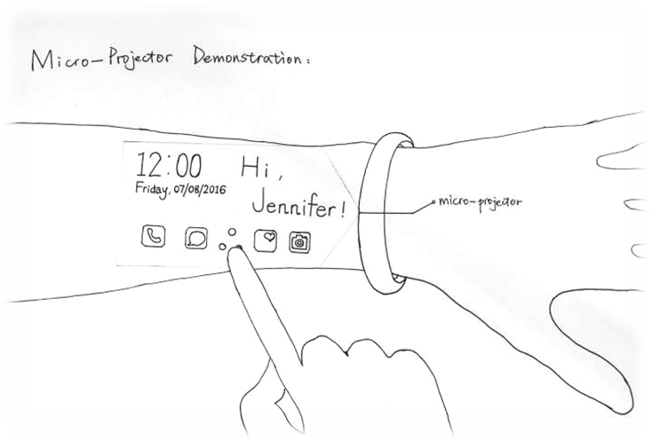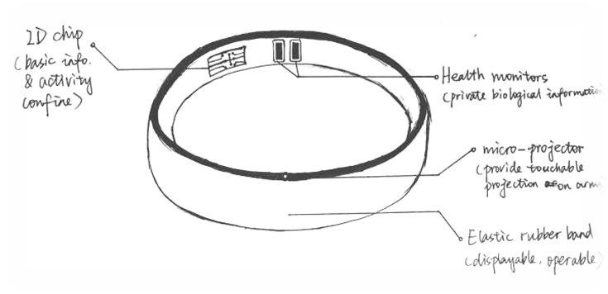

5.3.4 Watcher

The settled watchers are put on the walls , making sure that every area can be noticed .

The floating watchers are able to fly or hover around to check more comprehensively . The watchers are all able to connect with network .

5.3.5 Everyday Life

"Best friend" robot

The "Best friend" can provide various services . It feeds back information with all kinds of languages for human-computer interaction in human voice . It has the capability to identify user's voice command .

Major function :

① Simple housework . The "Best friend" can help do chores indoor . It has a vacuum sweeper and it can test the dust around and the quantity in order to work efficiently .

② Basic interior decoration . The "Best friend" can finish some basic tasks , including wall whitewashing and air brushing .

③ Education and entertainment . The "Best friend" can have intelligent conversations with users , teatching children at different ages all kinds of subjects with various information at different levels . Some information can be presented by a micro-projector carried by the "Best friend" . The "Best friend" runs applications for relaxing with holographic projection technique .

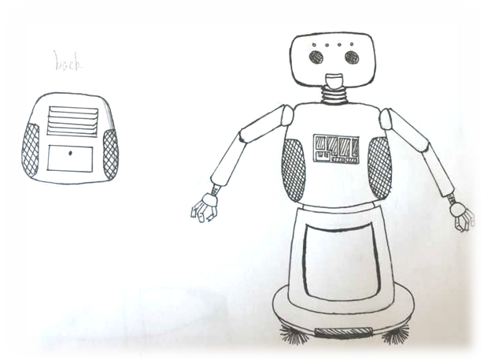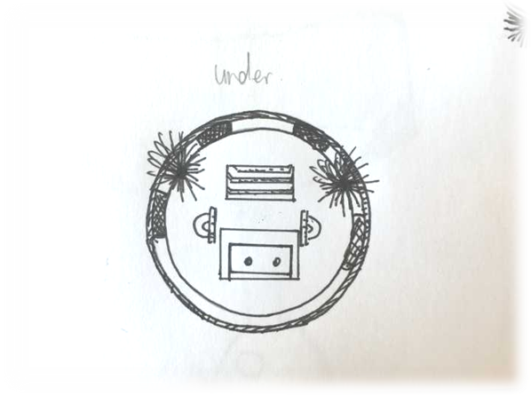

*comparative analysis

holographic projection VS touch screen

|  |  |  |
| --- | --- | --- |
|  | Holographic Projection | Normal Touch Screen |
| Display Effect | Stereo , vivid , has nice impression of space | Two-dimensional , contrived , things to display are limited |
| Human-computer Interaction | Users don’t need 3D glassed to experience its service | Users have to send their instructions by touching the screen |
| Display Space | Without limits | Restrictive |

5.3.5 Emergency robot

The emergency robot named "first-aider" carries a medicine cabinet for emergency rescue . It has a scanning instrument with capability of checking the conditon of an injury and judging which kind of medicine or measures to take .

The microchips in the "first-aider" involves position information of fire hydrant placed in SS . The ditector on the watchers can find the place caught fire and report it to the control center , then ACC will command SS to send out "first-aider" s after confirming the information .

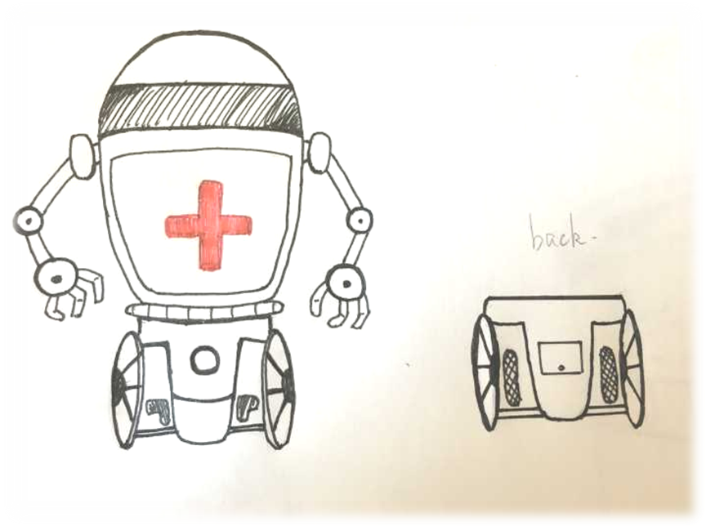

5.3.6 Outdoor ddecoration can be finished by the "first-aider" , too .

5.4 Reardonium Manufacturing Process

5.4.1 unloading the raw ore arriving from Mecury

The aerocraft has a movable case inside , which contains masses of reardonium parts . The case can be unloaded by the mechinery arms , and it can be reused through the circulatory system . The cases with reardonium inside can be delivered to the manufacturing area on certain tracks .

5.4.2 delivering reardonium parts between production processes

The cases which are already empty can move on the tracks from one process station to another , loaded with parts processed by the previous process .

5.5 automation on Mercury surface

5.5.1 Mercury surface robot

Robots working on the surface of Mercury are designed to two categories: Reardonium Collector and Reardonium Detector.

Reardonium Detectors can detect the location, size and the landscape-looking of ore. They also own intelligent system to order Reardonium Collectors to excavate the ore, load and upload the crude-refined ore on vehicles.

5.5.2 Mercury crude-refined factory

(1)Mercury crude-refined factory(master station)would be revised perticularly to ensure affects to robots: a half-soccer like solar panel umbrella would extend for generating and protection.

(2)Sub-base would also be built on where plenty of Reardonium is discovered. Robots would utilize eplosive to creat an enormous hole near the ore. On the top of that, Reardonium Collector would excavate the flank of the hole in order to construct the initial space of Sub-base. Sub-base would creat a safe place for robots working both during the day and night.

(3)a special aircraft which can detect the metals and has the laser gun to make a deep hole that can be arranged a microbump

(4)there isn’t any specialized mechine for digging, just a digging arm which must be connected with the transport vehicles,then it can work.

（5）there is a special system ,the computer control center will make the most efficient choices about the time, the distance and so on.

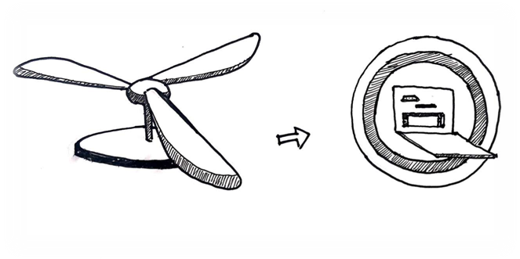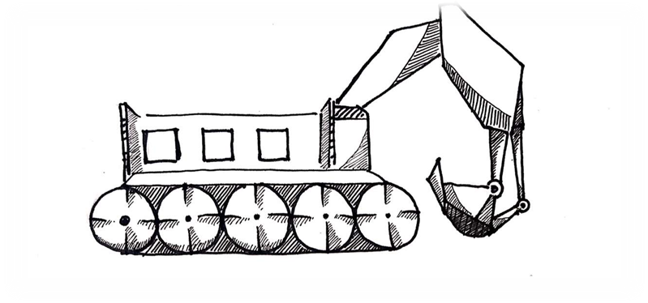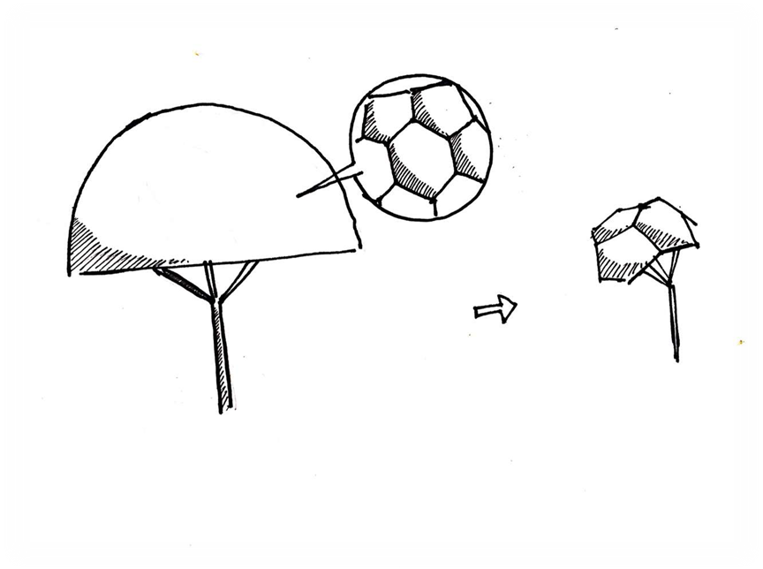

az

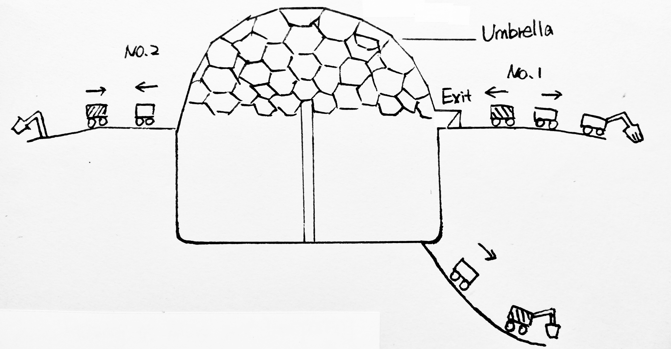

6.0 schedule and cost

6.0 schedule and cost

the schedule must describe contractor tasks from the time of contract award until the customer assumes responsibility for operations of the completed settleme8nt. Show schedule dates when Foundation Society members may begin moving into their new homes ,and when the entire original population will be established in the community..

6.1 Schedule

The planningregarding theconstruction of Aynah

will start on 3 January，2077；one day after the contract is awarded （2 January，2077）.Though planning and series of steps ，Aynah will be ready for human habitation just within 21 years .The following chart shows different construction phases and time taken to complete each phase.

|  |  |  |  |  |  |  |  |  |  |  |  |  |  |  |  |  |  |  |  |  |  |  |  |  |  |  |  |  |  |
| --- | --- | --- | --- | --- | --- | --- | --- | --- | --- | --- | --- | --- | --- | --- | --- | --- | --- | --- | --- | --- | --- | --- | --- | --- | --- | --- | --- | --- | --- |
| **Contract**  **Awarded** | **77** | **78** | | **79** | **80** | | **81** | **82** | **83** | **84** | **85** | | **86** | **87** | | **88** | **89** | | **90** | **91** | | **92** | | **93** | **94** | | | **95** | |
| **Planning** |  |  | |  |  | |  |  |  |  |  | |  |  | |  |  | |  |  | |  | |  |  | | |  | |
| **Hiring Workers** |  |  |  |  |  | |  |  |  |  |  | |  |  | |  |  | |  |  | |  | |  |  | | |  | |
| **Training**  **Workers** |  |  |  |  |  | |  |  |  |  |  | |  |  | |  |  | |  |  | |  | |  |  | | |  | |
| **Research** |  |  | |  |  | |  |  |  |  |  | |  |  | |  |  | |  |  | |  | |  |  | | |  | |
| **Construc-ting**  **Machiner-y** |  |  | |  |  |  |  |  |  |  |  | |  |  | |  |  | |  |  | |  | |  |  | | |  | |
| **Constructing Robots** |  |  | |  |  |  |  |  |  |  |  | |  |  | |  |  | |  |  | |  | |  |  | | |  | |
| **T esting Machinery** |  |  | |  |  |  |  |  |  |  |  | |  |  | |  |  | |  |  | |  | |  |  | | |  | |
| **T esting Robots** |  |  | |  |  |  |  |  |  |  |  | |  |  | |  |  | |  |  | |  | |  |  | | |  | |
| C**onstconstruction**  **Shack** |  |  | |  |  | |  |  |  |  |  | |  |  | |  |  | |  |  | |  | |  |  | | |  | |
| **Exterior**  **Construction** |  | | | | | | | | | | | | | | | | | | | | | | | | | | | | |
| **Phase1** |  |  | |  |  | |  |  |  |  |  | |  |  | |  |  | |  |  | |  | |  |  | | |  | |
| **Phase2** |  |  | |  |  | |  |  |  |  |  | |  |  | |  |  | |  |  | |  | |  |  | | |  | |
| **Phase3** |  |  | |  |  | |  |  |  |  |  |  |  |  | |  |  | |  |  | |  | |  |  | | |  | |
| **Phase4** |  |  | |  |  | |  |  |  |  |  |  |  |  |  |  |  | |  |  | |  | |  |  | | |  | |
| **Phase5** |  |  | |  |  | |  |  |  |  |  | |  |  |  |  |  | |  |  | |  | |  |  | | |  | |
| **Phase6** |  |  | |  |  | |  |  |  |  |  | |  |  | |  |  | |  |  | |  | |  |  | | |  | |
| **Phase7** |  |  | |  |  | |  |  |  |  |  | |  |  | |  |  |  |  |  | |  | |  |  | | |  | |
| **Agricultural Utilities** |  |  | |  |  | |  |  |  |  |  | |  |  | |  |  |  |  |  | |  | |  |  | | |  | |
| **Agricultural Growth** |  |  | |  |  | |  |  |  |  |  | |  |  | |  |  | |  |  | | | | | | | | | |
| **Phase8** |  |  | |  |  | |  |  |  |  |  | |  |  | |  |  | |  |  |  |  | |  |  | | |  | |
| **Phase9** |  |  | |  |  | |  |  |  |  |  | |  |  | |  |  | |  |  |  |  | |  |  | | |  | |
| **Testing Exterior** |  |  | |  |  | |  |  |  |  |  | |  |  | |  |  | |  |  | |  |  |  |  | | |  | |
| **Internal Construction** |  | | | | | | | | | | | | | | | | | | | | | | | | | | | | |
| **Industrial** |  |  | |  |  | |  |  |  |  |  | |  |  | |  |  | |  |  | |  |  | | |  | |  | |
| **Residential** |  |  | |  |  | |  |  |  |  |  | |  |  | |  |  | |  |  | |  | |
| **Testing** |  |  | |  |  | |  |  |  |  |  | |  |  | |  |  | |  |  | |  | |  |  |  | |  | |
| **Human Habitation** |  |  | |  |  | |  |  |  |  |  | |  |  | |  |  | |  |  | |  | |  |  |  | |  |

in progress

|  |
| --- |
|  |

construction

|  |
| --- |
|  |

in use

|  |
| --- |
|  |

6.2 Cost

The contractor has accounted for all the costs required to complete the tasks. The Foundation Society will be billed with a total of just $161.25 billion which is significantly less. This cost accounts for all the construction work along with planning, research, hiring and training workers. .

**Table 6.2.1 – Construction Cost of Aynah**

|  |  |  |
| --- | --- | --- |
| **Phase** | **Cost（**$ ） | **No.of Employees** |
| **Planning** | 3.5M | 80 |
| **Hiring Workers/Training Workers** | 252M | 1500 |
| **Research** | 2500M | 200 |
| **Construction Shark** | 6500M | 300 |
| **Construction of Machinery/Robots** | 10250M | 800 |
| **Exterior Construction** | | 1000 |
| **Phase1** | 7500M |  |
| **Phase2** | 3000M |  |
| **Phase3** | 2500M |  |
| **Phase4** | 6000M |  |
| **Phase5** | 2000M |  |
| **Phase6** | 4000M |  |
| **Phase7** | 3250M |  |
| **Phase8** | 2000M |  |
| **Phase9** | 3000M |  |
| **Interior construction** | | 1100 |
| **Residential construction** | 19000M |  |
| **Agricultural construction** | 16000M |  |
| **Industrial construction** | 25000M |  |
| **Testing** | 45M | 80 |
| **Habitation** | 15450M |  |
| **Construction Materials** | 16000M | 450 |
| **Acquiring Water** | 9000M | 80 |
| **Agricultural Production** | 8000M | 200 |
| **Total Cost** | **161.25Billion** | |

7.0 - Business Development

7.0 - Business Development

As the primary business and banking center in space, Aynah features a business model that serves as the foundation to extraterrestrial economy. Future business development opportunities will be based on the following nine components:

Customer Segments

Aynah has two main customer segments: Full-time residents and visiting guests. While there are certainly sub-groups within each segment, length of stay is nevertheless the key differentiator.

Value Propositions

To full-time residents, Aynahwill serve as a reliable and safe base to their life in outer space. To visiting guests, it will be the ultimate tourist destination as well as a “Singapore-in-orbit,” a first-rated financial mega-hub that also acts as a key transportation center for space ventures and personnel.

Channels

Foundation Society will be responsible for the promotion of Aynah Whether it is to attract full-time residents or visiting guests, The Society will communicate its messages to the intended audiences via its departments on Earth and other Settlements.

Customer Relationships

There will be “Resident and Guest Service Centers” strategically placed across Aynah to ensure maximum customer satisfaction. These centers will handle requests and solve problems that prevent residents and guests from enjoying their stay on the Settlement. Customers also have the option to do so via the web.

Mercury-view project

There are six ports on the original center. There are also six intervals between the ports.the intervals’ metal cover can open leaving glass on the top so that the visitors can have a good view of Mercury.

Revenue Streams

Aynahwill derive the majority of its revenues from the following sources:

Transportation Node and Port (Usage fees): docking, warehousing, cargo-handling, rest and recreation facilities.

Commerce and Financial Center (Rent and Service Usage Fees): offices, banks, headquarters, network connection.

Space Elevator (Transportation and Usage Fees): Raw material and personnel transportation, usage and consumption of in-elevator equipment and refreshments.

ICG Monetization Ecosystem (Usage and Service Fees): goods transaction, computer specification upgrades, AynahLine.

Key Resources

In order to generate the aforementioned revenue streams, Aynah will require operational, maintenance, and management personnel, who bring along knowledge and experience from previous involvement with other Settlements.



Key Activities

In addition to cultivating satisfied customers, operating, maintaining, and managing the Transportation Node and Port, Commerce and Financial Center, Space Elevator, and the ICG monetization Ecosystem will ensure steady cash flow into Aynah

Key Partnerships

For Aynah to succeed as the primary business and banking center in space, it will need support from Foundation Society, Countries which invested into the construction of the Settlement, as well as Corporate Investors (if any). It will also operate cooperatively along with other Settlements to achieve maximum productivity for all Foundation Society-run Settlements.

Cost Structure

Aynahwill incur the majority of its costs from the following sources:

1. Operation: salaries and wages, energy (if outsourced), etc.
2. Maintenance: Settlement repair and expansion, etc.
3. Marketing: Research, Promotion, etc.